Protect Yourself

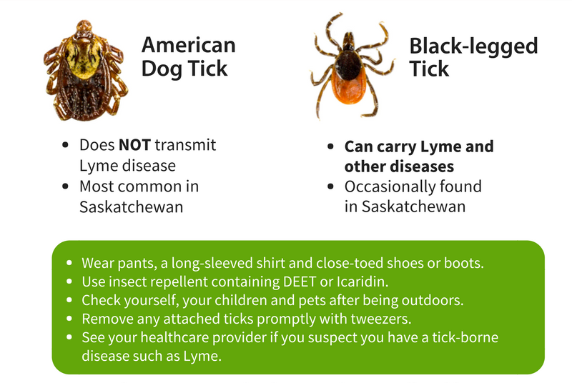

When returning from the outdoors:
- Shower or bathe within two hours.
- Do full-body tick checks daily on yourself, your children, and pets. Some ticks are quite small, so look carefully.
- Put your clothes in a hot dryer or hang them in the sun on a hot day for at least 15 minutes to kill the ticks. Also check any gear you had with you in the woods.

For more information, visit www.saskatchewan.ca/lyme or call HealthLine 811.

